1. Introduction

1.1 Background

£1m has been secured from three investors who wish to invest in a new Indian restaurant, named Chapati On!, to be located somewhere in Manchester, England.

1.2 Problem

The investors wish to understand the Manchester area, specifically to inform them of the best location for Chapati On!

Foursquare.com hosts venue data for restaurants and other eating establishments, as well as other attractions and venues in a given area.

Foursquare has 128 restaurants in the Manchester area, of which 14 are Indian restaurants.

2. Data

2.1 Data sources

I will scrape www.wikipedia.org/wiki/M_postcode_area for postcode data in the Manchester area.

I will add latitude and longitude data using data from www.freemaptools.com/download-uk-postcode-lat-lng.htm.

I will then add venue location data from www.foursquare.com.

2.2 Data cleaning

From the postcode data, I dropped all postcodes which were not physical areas eg postbox numbers.

I also dropped duplicate rows of the same post code.

As the investors wish Chapati On! to be located in Manchester itself, I dropped rows of data relating to nearby towns of Salford and Sale.

The data had some hidden code at the end of the data strings ('/n' denoting a new line) which I cleaned to enable the data to be merged with the latitude and longitude data.

The co-ordinates dataset contained latitude and longitude data for all postcodes in the UK. I dropped the irrelevant data and looked only at those relating to Manchester postcodes.

3. Methodology

3.1 Initial merge

After cleaning the postcode data as described above, I was left with 36 postcode areas to explore.

I merged the postcode data with the latitude and longitude data, and used these co-ordinates of the different postcodes to obtain nearby venue data from Foursquare.com.

This provided me with 515 venues across the 36 postcodes.

The spread of these across the top ten most densely populated postcodes looks like this. We can see that postcode areas M1, M2, M3 and M4 have the highest number of venues.

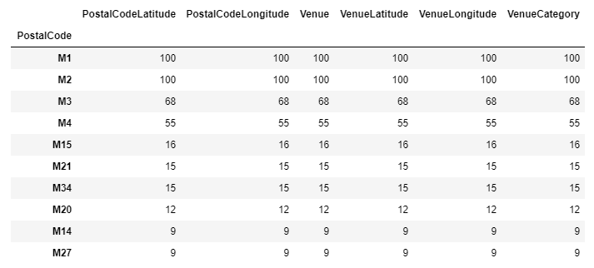

3.2 Restaurant data

I extracted the venue data which indicated a restaurant or other evening eating establishment, resulting in 128 venues.

I further extracted data relating to Indian restaurants, of which there are 14.

I plotted these on a map to visualise the spread of restaurants. Indian restaurants are marked in orange; other types of eating establishments are marker in blue/yellow.

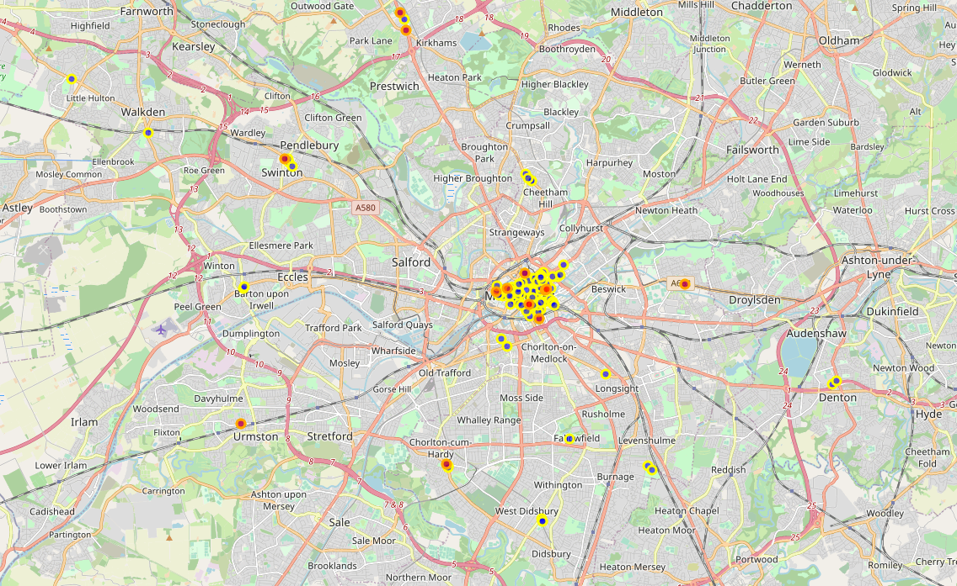

3.3 Areas with a high density of restaurants

I explored those postcode areas with the highest number of restaurants.

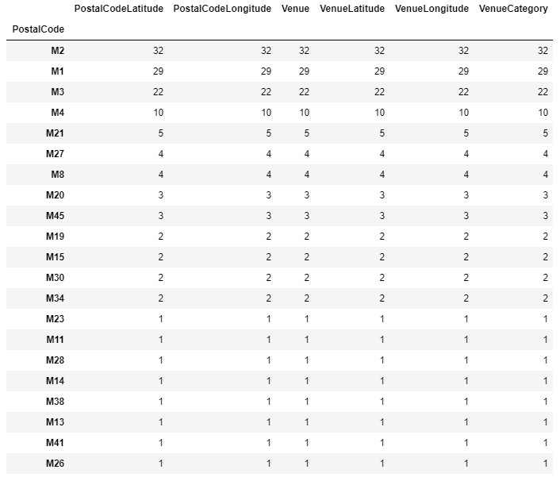

3.4 Explore areas with large number of restaurants

The postcode areas with the highest number of restaurants are also M1, M2, M3 and M4. There are 93 restaurants in these four areas in total, including 8 Indian restaurants.

I mapped these to visualise their spread.

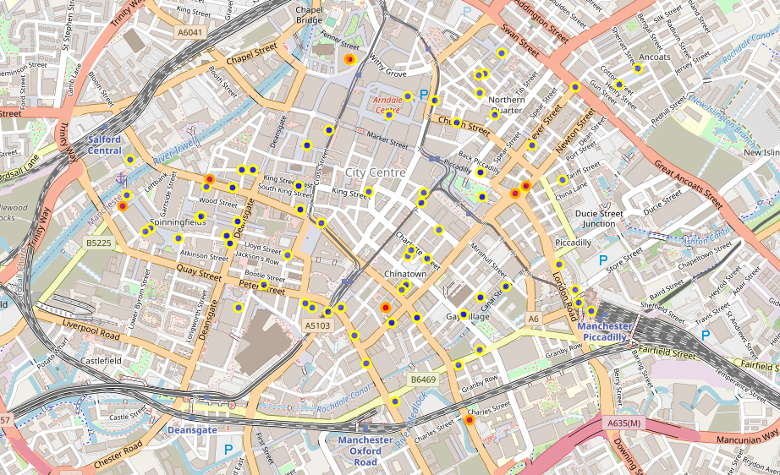

4. Results

4. 1 Areas to focus on

From the map visualisations, it is clear that there are no Indian restaurants in several of the areas which have other restaurants nearby.

These areas are the Northern Quarter, Spinningfields, and Manchester Piccadilly, as shown below.

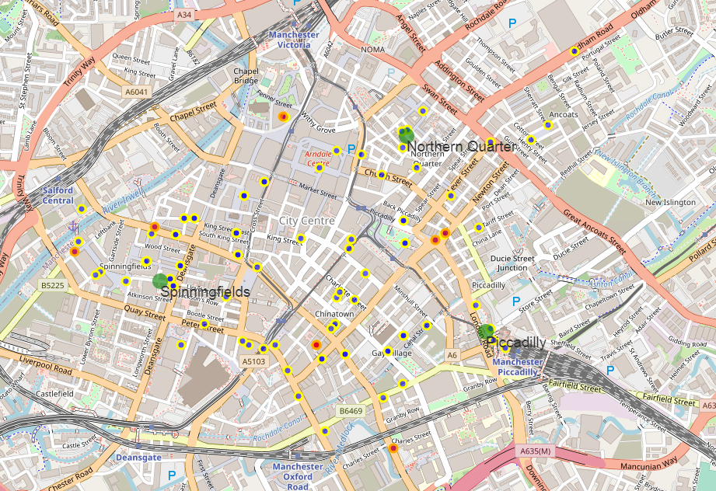

4.2 Other venues in these three areas

I used Foursquare.com to extract data regarding non-restaurant venues in the areas of Northern Quarter, Spinningfields and Piccadilly.

There are 168 of these, across the areas.

I used onehot encoding to establish which types of venue appeared most frequently in each area, up to the 10th most frequent type of venue. The results are as follows:

5. Discussion

Analysing the types of other venues in each of the different areas, Manchester Piccadilly has the most drinking establishments (ie bar or pub) nearby compared to the other two areas.

Piccadilly is also close to the train station, which increases accessibility to the area.

The recommendation to the investors of Chapati On! is therefore to locate the restaurant in the Manchester Piccadilly area.

6. Conclusion

Manchester Piccadilly appears to offer the best opportunity for the investors of Chapati On! as the area has a high number of restaurants, but no other Indian restaurants. Its proximity to the train station increases its accessibility.

